SATISH KUMAR
MCA 2nd SEMESTER ,ROLL NO- 244CA046
Exercise- 2

1. List all students with a total credit count of 0.

>> select * from student where tot_cred>0 and rownum<10;

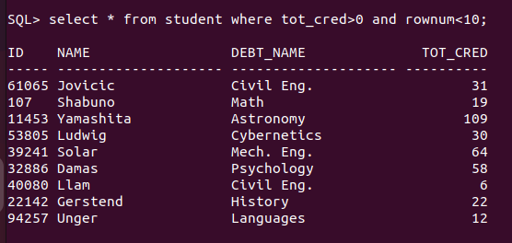

2. Find the names of all courses offered by the "Physics" department.

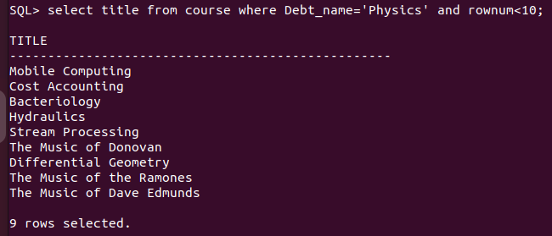

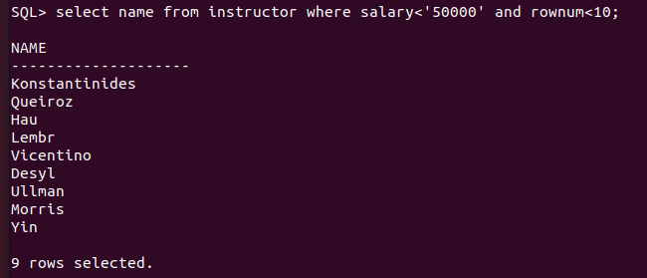
3. Retrieve the names of all instructors who earn less than ₹50,000.

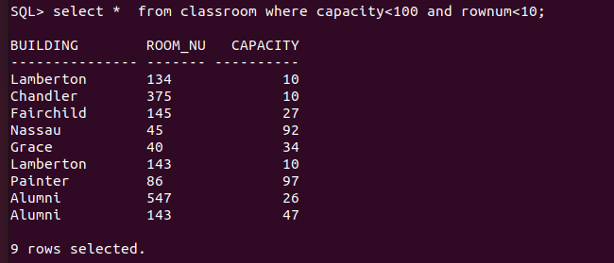
4. List all classrooms with a capacity of exactly 100.

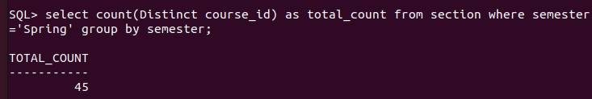
5. Find the total number of courses offered in the "Summer" semester.

6. List all students who have taken exactly 30 total credits.

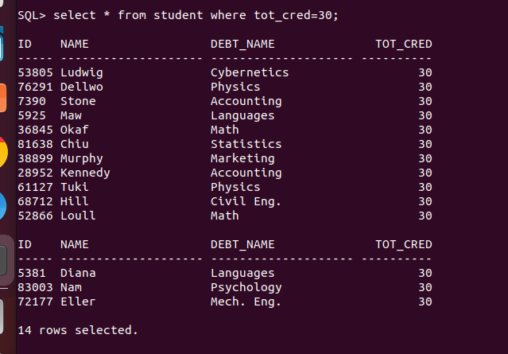

7. Find the names of all courses offered by the "Math" department.

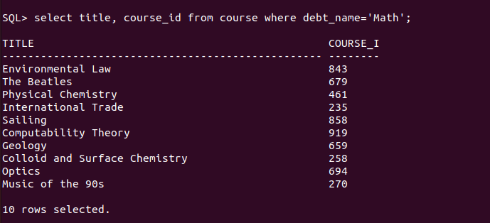

8. Retrieve the names of all instructors who earn more than ₹100,000.

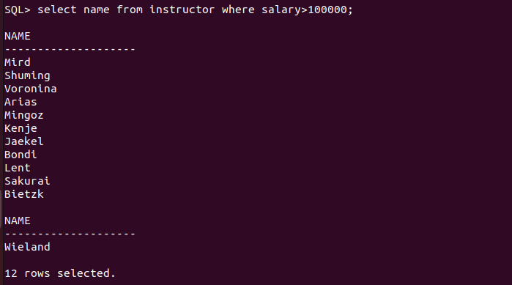

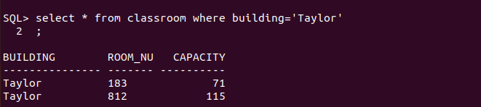
9. List all classrooms located in the "Taylor" building.
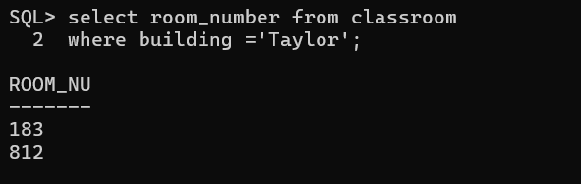

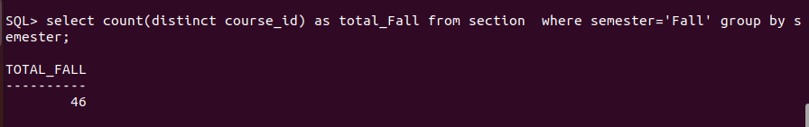
10. Find the total number of courses offered in the "Winter" semester.

11. List all students who have taken courses with a grade of "C" or lower.

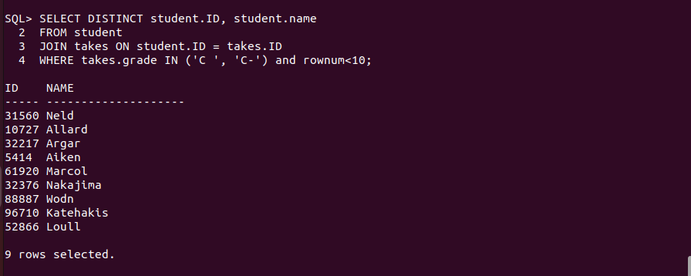

12. Retrieve the names of instructors who have taught in the "Fall" semester of 2022.
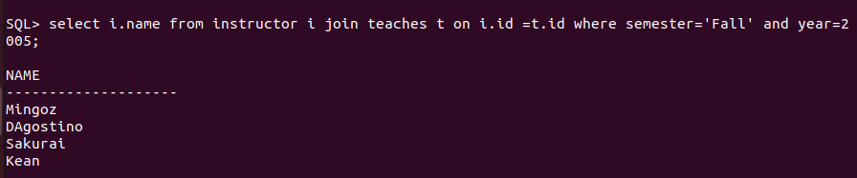

13. Find the average capacity of classrooms in each building.

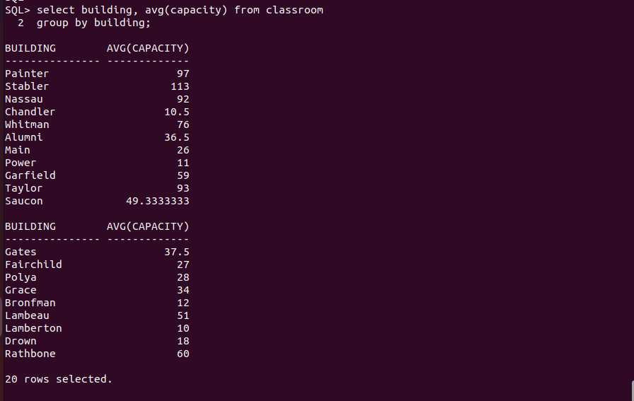

14. List all courses that have more than 3 credits.
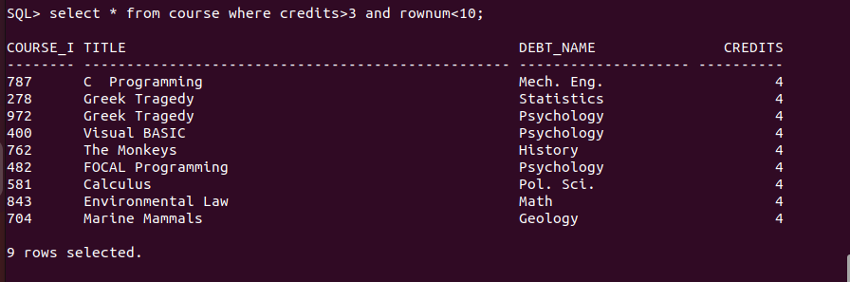

15. Retrieve the names of students who have taken courses in the "Watson" building.
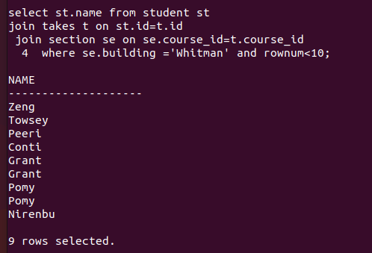

16. Find the total number of students advised by each instructor.

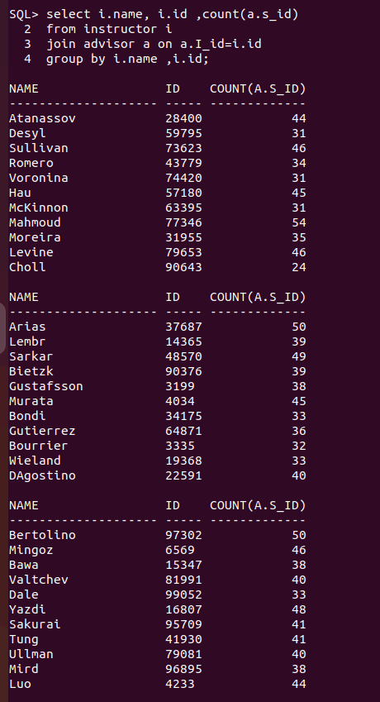

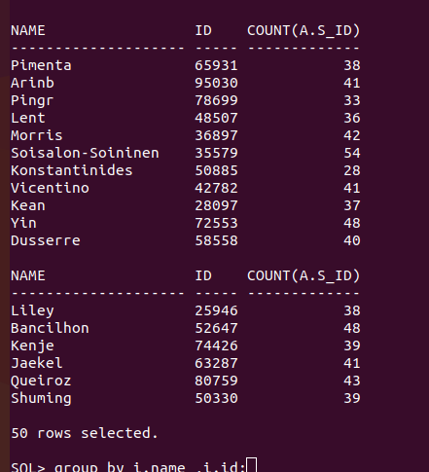

17. List all sections that do not have a classroom assigned.
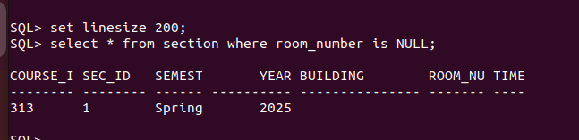
18. Retrieve the names of students who have taken courses with the highest number of
credits.

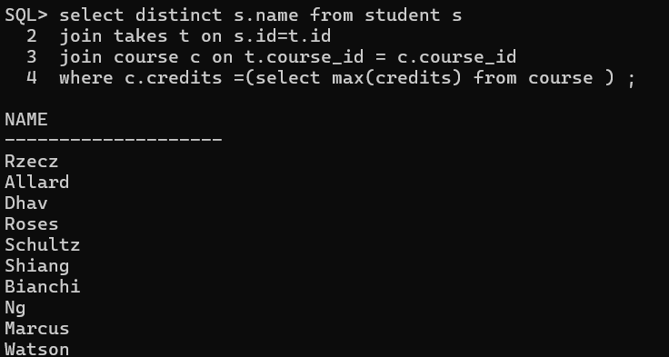

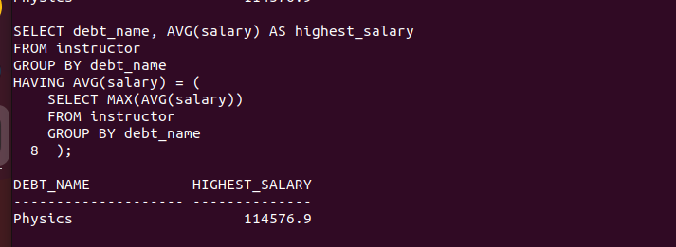
19. Find the departments with the highest average instructor salary.

>>method -2
CREATE VIEW avg_dept_instructor_salary AS
SELECT dept_name, AVG(salary) AS avg_salary
FROM instructor
GROUP BY dept_name;

SELECT dept_name, avg_salary
FROM avg_dept_instructor_salary
WHERE avg_salary = (SELECT MAX(avg_salary) FROM avg_dept_instructor_salary);

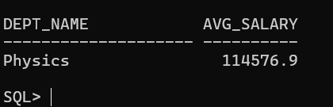

20. List all courses that have been taught by more than one instructor.

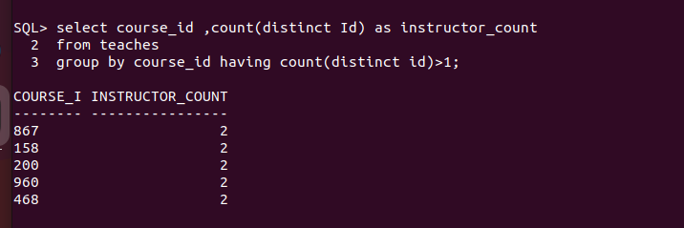

21. List all students who have taken courses with a grade of "A" in the "Fall" semester of
2022.

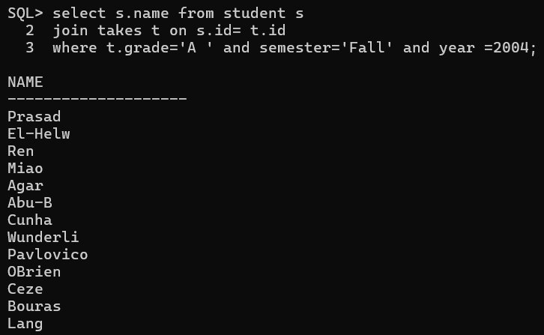

22. Retrieve the names of instructors who have taught in the "Spring" semester of 2023.
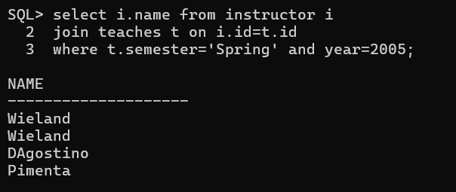

23. Find the average number of students enrolled in each course.

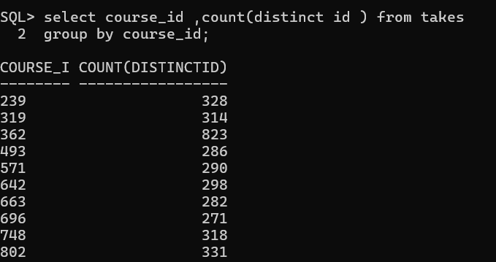

24. List all courses that have exactly 4 credits.

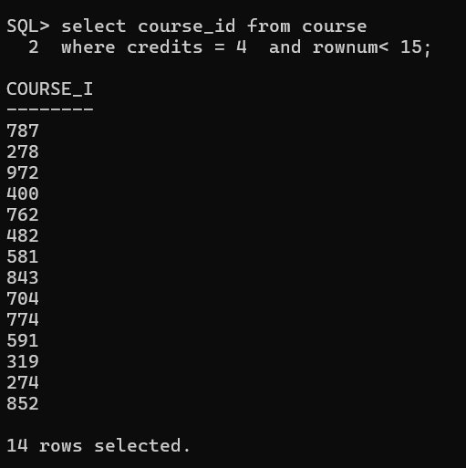

25. Retrieve the names of students who have taken courses in the "Taylor" building.
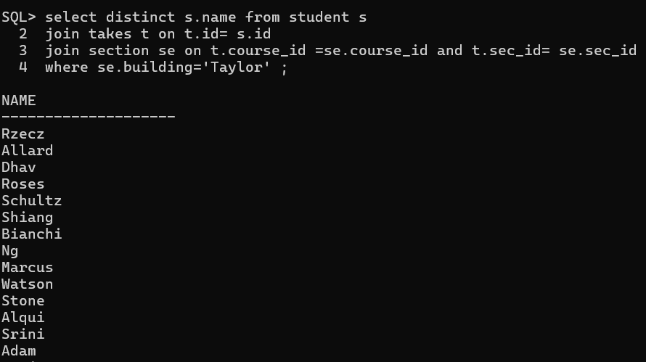
26. Find the total number of sections taught by each instructor.

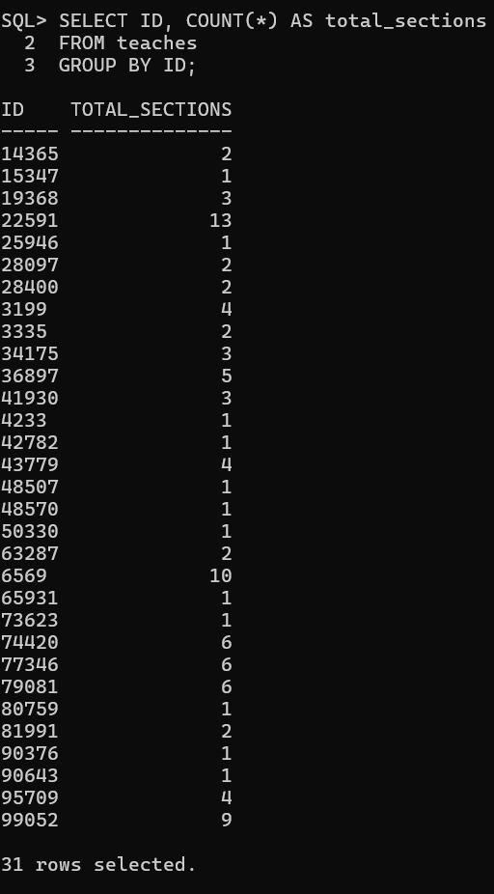

s27. List all sections that are held in rooms with a capacity of less than 50.
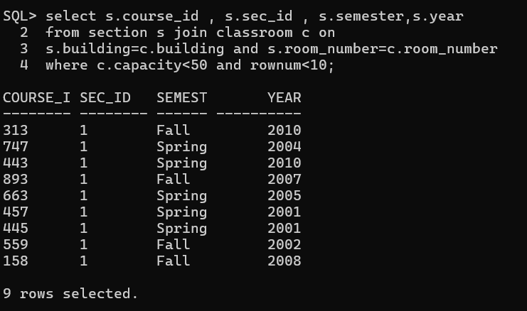

28. Retrieve the names of students who have taken courses with the lowest number of credits.
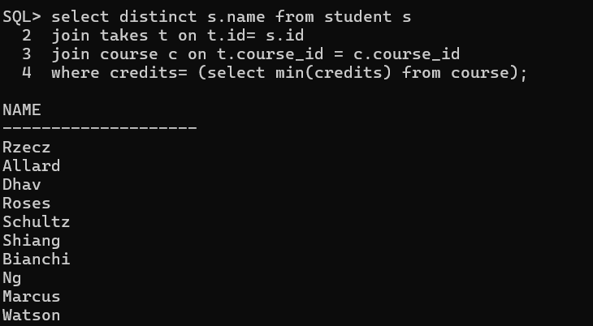

29. Find the departments with the lowest average instructor salary.
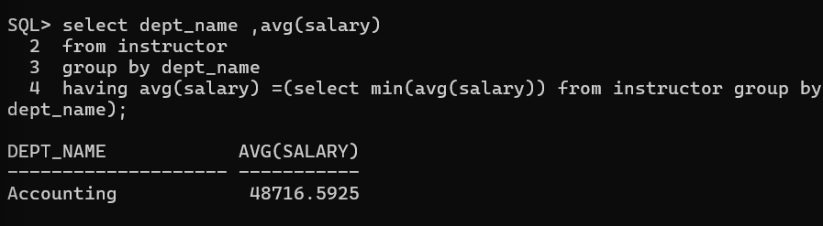

30. List all courses that have been taught by only one instructor.
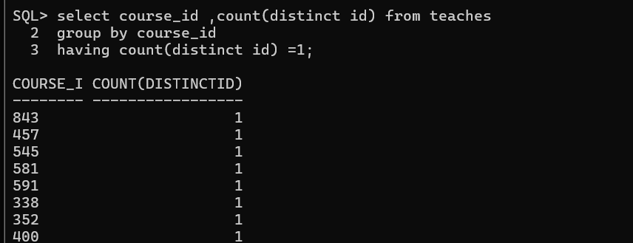

31. Find the students who have taken courses with every instructor in the university.
>>>>>

SELECT t.ID, s.name
FROM takes t
JOIN student s ON t.ID = s.ID
JOIN teaches te ON t.course_id = te.course_id
GROUP BY t.ID, s.name
HAVING COUNT(DISTINCT te.ID) = (SELECT COUNT(*) FROM instructor);

32. Retrieve the names of instructors who have taught courses in all available semesters.
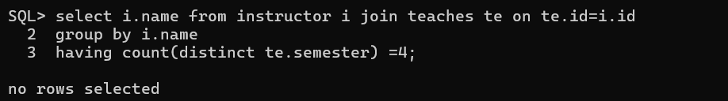

33. List all courses that have been taught in every building.
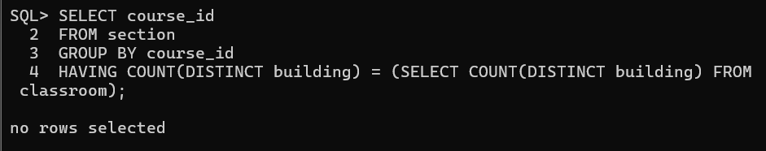

34. Find the students who have taken the most number of courses in a single year.

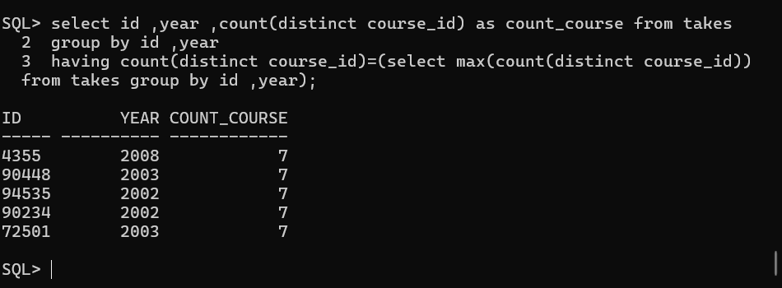

35. Retrieve the names of students who have taken courses with overlapping time slots in the same semester.

36. List all courses that have been taught by the same instructor in consecutive semesters.

37. Find the departments where the total student credits are less than the department budget.

38. Retrieve the names of students who have taken courses with every time slot.

39. List all courses that have been taught in every year.

40. Find the students who have taken the most number of courses with the same instructor.

41. Find the students who have taken courses from at least 3 different departments.

42. Retrieve the names of instructors who have taught the same course in consecutive years.

43. List all courses that are prerequisites for exactly 2 other courses.

44. Find the departments where the total student credits are equal to the department budget.

45. Retrieve the names of students who have taken courses with every time slot in a single semester.

46. List all courses that have been taught in every building except one.

47. Find the students who have taken the most number of courses in a single department.

48. Retrieve the names of instructors who have taught courses in all available time slots.

49. List all students who have taken courses with overlapping time slots in different semesters.

50. Find the courses that have the lowest enrollment across all semesters.

